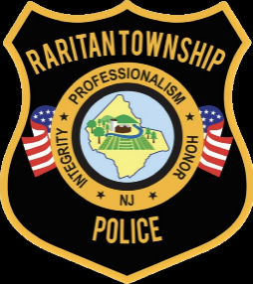
RARITAN TOWNSHIP POLICE DEPARTMENT

Recruitment Plan
Goal:

The Raritan Township Police Department intends to attract qualified individuals for a career in law enforcement. The department prioritizes a recruitment and selection process that is diligently focused on identifying and reducing the presence of substantial disparities to achieve a diverse workforce, in terms of people of color and gender diversity. Conclusively the department’s goal is to achieve a structure of law enforcement officers that is representative of the population of the community served. The department is governed by N.J.S.A. 40A:14-118 et. seq. and Ordinances of Raritan Township regarding recruitment initiatives and appointment. The Raritan Township Police Department is an Equal Opportunity Employer.

Comparative Analysis to identify Substantial Disparity for Underrepresented Group(s) is as follows:
(source: https://www.census.gov/quickfacts/fact/table/raritantownshiphunterdoncountynewjersey/RHI825219#RHI825219):
Race / Ethnicity/ | Service Population |  | Sworn Officers
 | # | % | # Male |  | # Female |  | Total | Percentage
American Indian or Alaska Native | 73.9 | 0.3% | 0 | 0.00% | 0 | 0.00% | 0 | 0.00%
Asian | 2241.9 | 9.1% | 1 | 2.4% | 0 | 0.00% | 1 | 2.4%
Black or African American | 714 | 2.9% | 1 | 2.4% | 0 | 0.00% | 1 | 2.4%
Hispanic or Latino (any race) | 2315.8 | 9.4% | 2 | 4.8% | 1 | 50% | 3 | 6.9%
Native Hawaiian or other Pacific Islander | 0 | 0.00% | 0 | 0.00% | 0 | 0.00% | 0 | 0.00%
White (non Hispanic) | 18724.1 | 76% | 36 | 87.8% | 1 | 50% | 37 | 86%
Two or more races | 1872.4 | 7.6% | 1 | 2.4% | 0 | 0.00% | 1 | 2.4%
Total | 24637 | 100% | 41 | 95.3% | 2 | 4.6% | 43 | 100%

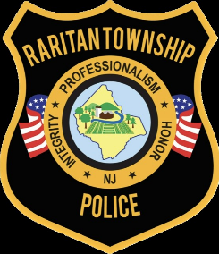
RARITAN TOWNSHIP POLICE DEPARTMENT

Gender | Service Population
 | # | %
Male | 11728 | 47.6%
Female | 12909 | 52.4%
Total | 24637 | 100.00%

In review, a determination is made that there is currently a substantial disparity existing, between the department’s sworn officers in correlation to the population of Raritan Township, for the following underrepresented groups:

Females:
Female Population in Raritan Township: 52.4%
Female Sworn Officers: 4.6%

Asian:
Asian Population in Raritan Township: 9.1%
Asian Sworn Officers: 2.4%

Two or More Races:
Two or More Races in Raritan Township: 7.6%
Two or More Races Sworn Officers: 2.4%

- Recruitment Initiative Actions:
- Training:
All officers, including those selected to serve as part of the recruitment intiative will be trained in implicit and explicit bias.
- Standardized Forms:
The department currently utilizes Facebook, the department website, and Police App for recruitment initiatives. Application and Personal History Statement forms and documents will be standardized to reduce subjective responses.
- Strategic Community Outreach and Engagement:
Law enforcement officer organizations will be contacted to expand accessiblity to underrepresented groups with the goal of soliciting a greater applicant pool of from those underrepresented groups. Additionally this strategic community outreach and engagement will also serve as engaging community statekholders as well as consulting a diverse hiring team to assess what barriers to the application process exists for underrepresented groups and developing solutions to overcome those barriers.

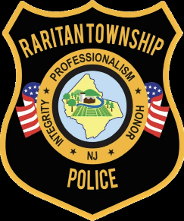

- Predictive Barriers & Solutions:
Publicly posted applicant resources on department website:
- Application submission challenges and circumstances such as technical or equipment availability issues. The department will make alternative methods available such as onsite resume submission at headquarters.
- Resume assistance – the Department of Labor and Workforce Development https://www.nj.gov/labor/career-services/tools-support/resume/
RARITAN TOWNSHIP POLICE DEPARTMENT
- Program Review:

- Annually the Chief of Police, or their designee, shall analyize the Recruitment Plan:
- Number of applicants comparative to the underrepresentated groups, as determined by the comparative analysis;
- Number of appointments comparative to the underrepresentated groups, as determined by the comparative analysis;
- Effectiveness of reducing substantial dispartity for identified underrepresented groups;
- Redesign of the Recruitment Plan as determined.

